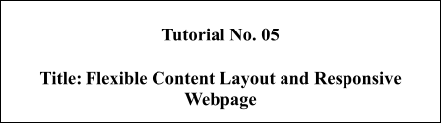

**Batch:B2 Roll No.: 16010421119 Tutorial No.: 5**

**Aim**: To design flexible content layout and responsive web pages.

**Resources needed: Notepad++, Web Browser**

**Theory:**

**Responsive Web Design-**The goal of a responsive layout is to function well on every single device. Regardless of screen size or resolution, your responsive designs should always be usable.

Focus on usability for every single aspect of your site. This may be easier starting with mobile-first because you’re designing for limited features, then moving up to desktop which supports a wider screen size.

**Flex Layout Model-** CSS3 flexible Box, or flexbox is a new layout model for creating the more flexible user interface design with multiple rows and columns without using the percentage or fixed length values. The CSS3 flex layout model provides a simple and powerful mechanism for handling the distributing of space and alignment of content automatically through stylesheet without interfering with the actual markup.

**Activity**

Add grid layout, flex container and responsive property to the webpages

**Results: (Program printout with output)**

**<!DOCTYPE html>**

**<html lang="en">**

**<head>**

**<meta charset="UTF-8" />**

**<meta http-equiv="X-UA-Compatible" content="IE=edge" />**

**<meta name="viewport" content="width=device-width, initial-scale=1.0" />**

**<title>Document</title>**

**<link rel="stylesheet" href="styles2.css" />**

**</head>**

**<body>**

**<div class="image">**

**<div class="container">**

**<div class="row">**

**<div class="col">**

**<img src="https://images.unsplash.com/photo-1575936123452-b67c3203c357?ixlib=rb-4.0.3&ixid=MnwxMjA3fDB8MHxzZWFyY2h8Mnx8aW1hZ2V8ZW58MHx8MHx8&w=1000&q=80"**

**alt="image" id="media" />**

**</div>**

**<div class="col">**

**<video width="600" height="600" controls>**

**<source src="movie.mp4" type="video/mp4"/>**

**</video>**

**</div>**

**</div>**

**</div>**

**</div>**

**<div class="container">**

**<div class="row">**

**<div class="col">**

**<img src="https://images.unsplash.com/photo-1575936123452-b67c3203c357?ixlib=rb-4.0.3&ixid=MnwxMjA3fDB8MHxzZWFyY2h8Mnx8aW1hZ2V8ZW58MHx8MHx8&w=1000&q=80"**

**alt="image" class="media" />**

**</div>**

**<div class="col">**

**<img src="https://images.unsplash.com/photo-1575936123452-b67c3203c357?ixlib=rb-4.0.3&ixid=MnwxMjA3fDB8MHxzZWFyY2h8Mnx8aW1hZ2V8ZW58MHx8MHx8&w=1000&q=80"**

**alt="image" class="media" />**

**</div>**

**<div class="col">**

**<img src="https://images.unsplash.com/photo-1575936123452-b67c3203c357?ixlib=rb-4.0.3&ixid=MnwxMjA3fDB8MHxzZWFyY2h8Mnx8aW1hZ2V8ZW58MHx8MHx8&w=1000&q=80"**

**alt="image" class="media" />**

**</div>**

**<div class="col">**

**<img src="https://images.unsplash.com/photo-1575936123452-b67c3203c357?ixlib=rb-4.0.3&ixid=MnwxMjA3fDB8MHxzZWFyY2h8Mnx8aW1hZ2V8ZW58MHx8MHx8&w=1000&q=80"**

**alt="image" class="media" />**

**</div>**

**</div>**

**</div>**

**</body>**

**</html>**

**/* * {**

**box-sizing: border-box;**

**} */**

**.media {**

**width: 500px;**

**height: 500px;**

**}**

**.image {**

**width: 100%;**

**}**

**.grid-cont {**

**width: 100%;**

**text-align: center;**

**display: grid;**

**grid-template-columns: auto auto auto;**

**}**

**.grid-image {**

**width: 500px;**

**height: 300px;**

**}**

**.wrapper {**

**display: grid;**

**grid-template-columns: repeat(3, 400px);**

**grid-template-rows: repeat(3, 400px);**

**height: 500px;**

**width: 1000px;**

**gap: 20px;**

**grid-template-areas:**

**"a a b b b"**

**"a a b b b"**

**"c c d d d";**

**}**

**.item1 {**

**grid-area: a;**

**background-color: lightblue;**

**}**

**.item2 {**

**grid-area: b;**

**background-color: darkblue;**

**}**

**.item3 {**

**grid-area: c;**

**background-color: lightgreen;**

**}**

**.item4 {**

**grid-area: d;**

**background-color: darkgray;**

**}**

**/* Reset styles */**

**\* {**

**margin: 0;**

**padding: 0;**

**box-sizing: border-box;**

**}**

**@media (max-width: 576px) {**

**.media {**

**width: 100px;**

**height: 100px;**

**}**

**.wrapper{**

**grid-template-columns: repeat(2, 400px);**

**width: 500px;**

**}**

**}**

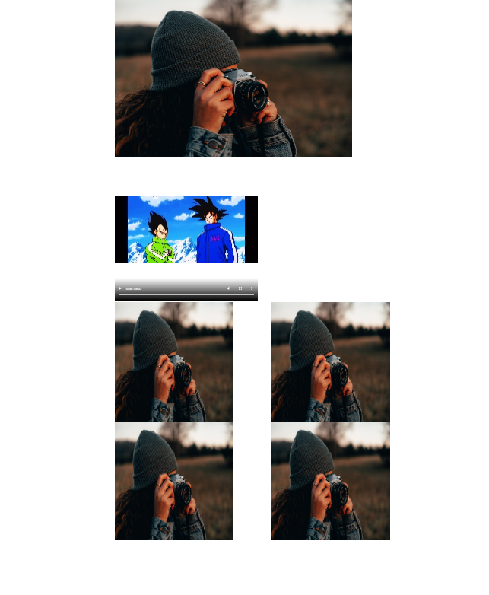

**Outcomes:**

**CO2: Create Web pages using HTML 5 and CSS**

**Conclusion: (Conclusion to be based on the outcomes achieved)**

**We can conclude that we have learnt about flexible layout and responsive designs**

**Grade: AA / AB / BB / BC / CC / CD /DD**

Signature of faculty in-charge with date

**References:**

**Books/ Journals/ Websites:**

* “Web technologies: Black Book”, Dreamtech Publications
* [http://www.w3schools.com](http://www.w3schools.com/)
* https://css-tricks.com/snippets/css/complete-guide-grid/
* <https://css-tricks.com/snippets/css/a-guide-to-flexbox/>